**CSC 5750 – Principles of Web Technology**

**Homework 2 – [Shruthi Manappa Baichbal]**

**25 points – Due October 3, 6pm**

**Late deadline is October 5, 11:59pm, but 20% off**

**a)** Save this document with your name and the homework number somewhere in the file name.

**b)** Type/paste your answers into the document.

**c)** Gather the following files into a ZIP file:

● This document

● Main page (.HTML)

● Tourist page (.HTML)

● Map page (.HTML)

● CSS file (.CSS)

● Image files

● Any other optional files specific to your implementation

**d)** Submit the ZIP file to the Blackboard item where you downloaded this document.

You've been hired by a city to create a web site that has the following three web pages:

● A **Main page** that contains general information about the city. This may include its location, year founded, population, land area, elevation, time zone, mayor, flag, etc. Include two or more images (not including the flag).

● A **Tourist page** that lists things to do or places to see in the city. Include two or more images.

● A **Map page** that marks the city on a map. This could be a Google map with an arrow pointing to the city.

Pick any city to feature. When creating the pages, begin with the provided HTML templates (main and other). Place a header with page title(s) at the top of each page. Place a footer with city name at the bottom of each page. Incorporate the following HTML elements on each page:

● Comments.

● Paragraphs.

● At least two of the six pre-defined heading styles.

● Links to the other two pages in a menu.

● Horizontal ruler(s).

● Within the Main page, a multi-column paragraph.

● Within the Tourist page, one or more unordered lists, and an e-mail link.

Place all styling attributes in a CSS file and connect it to the three HTML pages. Include the following properties in the CSS file:

● Font properties

● Text properties

● Color properties

● Background properties

● At least three .class styles.

● At least one :hover style.

**Main page Code**

*[<!DOCTYPE html>*

*<!--==================================================================*

*//*

*// Title: Webpage for Banglore City*

*// Course: CSC 5750*

*// Homework: 2*

*// Author: Shruthi Manappa Baichbal*

*// Date: 3 October 2017*

*// Description:*

*// The webpage talks about the Banglore City ,History and founder of the Banglore,History,climate.The Webpage also tells about the Present Politicains.Page Contains the many tourists place Image.*

*THe Header has the Logo of Banglore, and links for the other 2 pages,i,e Tourist Page and Maps.*

*This Webpage also contains the complete information about city.*

*// We have tables, and Go to links for the same page,Unordered lists.*

*Footer COntains information of the Web PageCreater, and Time to call the tourist consultant for any information*

*//*

*//*

*//=================================================================-->*

*<html>*

*<head>*

*<!-- Code to get the ICons form from google using font awesome and link to CSS Page-->*

*<title>Main page</title>*

*<link rel="stylesheet" href="https://cdnjs.cloudflare.com/ajax/libs/font-awesome/4.7.0/css/font-awesome.min.css">*

*<link href="https://fonts.googleapis.com/css?family=Oswald|Satisfy|Baloo+Tammudu|Play|Tangerine|Great+Vibes" rel="stylesheet">*

*<link rel="stylesheet" type="text/css" href="Test.css">*

*</head>*

*<body>*

*<div class="body-wrapper">*

*<header>*

*<!-- Logo of the Banglore City-->*

*<div class="logo-holder">*

*<a href="main.html">*

*<img src="image\banglorelogo.png">*

*<!--================================================================*

*// Pre-defined heading style h1*

*//===============================================================-->*

*<h1>Banglore- Garden and Silicon city </h1>*

*</a>*

*<!-- Link to another spot on this web page. The spot with ID*

*"EndOfPage" must exist somewhere in this HTML file. -->*

*<a href="#EndOfPage">Go to the end of the web page</a>*

*<p div id="BeginOfPage"></p>*

*</div>*

*<div class="header-list">*

*<ul>*

*<li><a href="Tourist page.html"><i class="fa fa-bus" aria-hidden="true"></i>Tourists Page</a></li>*

*<li><a href="Banglore Map.html"><i class="fa fa-map-marker" aria-hidden="true"></i>Maps</a></li>*

*</ul>*

*</div>*

*</header>*

*<!--================================================================*

*// Break line*

*//===============================================================-->*

*<div class="content-wrap">*

*<h1 class="deal-h1"> Banglore the coolest city ever </h1>*

*<div class="main-images">*

*<div class="scroller">*

*<img class="large-img" src="image\Banglore palace.jpg" alt="Image Missing for the banner!" />*

*<img class="large-img" src="image\Vidhana Soudha2.jpg" alt="Image Missing for the banner!" />*

*<img class="large-img" src="image\Iscon Temple.jpg" alt="Image Missing for the banner!" />*

*<img class="large-img" src="image\Manipal OCunty.jpg" alt="Image Missing for the banner!" />*

*<img class="large-img" src="image\Hogenikal Falls.jpg" alt="Image Missing for the banner!"/>*

*<img class="large-img" src="image\Lal Bhag.jpg" alt="Image Missing for the banner!" />*

*<img class="large-img" src="image\nandhi Hills.jpg" alt="Image Missing for the banner!" />*

*<img class="large-img" src="image\Shivatemple.jpg" alt="Image Missing for the banner!" />*

*</div>*

*<hr>*

*<br>*

*</div>*

*<hr>*

*<div class="scroll-right" >Scroll right to get an amazing offer!!! </div>*

*<!--================================================================*

*// Unordered lists*

*//===============================================================-->*

*<p><b>Few Places must be visited in Banglore</b></p>*

*<ul>*

*<li>Vidhan Soudha</li>*

*<li>Banglore Palace</li>*

*<li>Wonder La</li>*

*</ul>*

*<div class="history">*

*<p>History:</p>*

*<p>Bengaluru is the capital city of the state of Karnataka India. Bangalore (previously Bendakaluru), as a city, was founded by Kempe Gowda I, who built a mud fort at the site in 1537. But the earliest evidence for the existence of a place called Bangalore dates back to c. 890.[1]Bangalore explargest city in India, with a population of 1,207,000.*

*Kempe Gowda I (1510–1570), Modern Bangalore was founded by a feudatory of the Vijayanagara Empire, who built a mud fort in the year 1537. Kempe Gowda also referred to the new town as his "gandu bhoomi" or "Land of Heroes. </p>*

*</div>*

*<figure style="width:37%; height:100%; float: left; margin-top:8%;">*

*<img src="image\Bangalore1924_map.png" width="500px" height="500px"/>*

*<figcaption style="text-align: center; font-family: 'Play', sans-serif;"> Banglore Map During 1924</figcaption>*

*</figure>*

*<!--================================================================*

*// Horizonal ruler/divider*

*//===============================================================-->*

*<div class="history">*

*<p>Climate:</p>*

*<p>Bangalore lies in the southeast of the South Indian state of Karnataka. It is in the heart of the Mysore Plateau (a region of the larger Precambrian Deccan Plateau) at an average elevation of 900 m (2,953 ft).[60]:8 It is located at 12.97°N 77.56°E and covers an area of 741 km2 (286 sq mi).[61] The majority of the city of Bangalore lies in the Bangalore Urban district of Karnataka and the surrounding rural areas are a part of the Bangalore Rural district.*

*</p>*

*</div>*

*<figure style="width:37%; height:100%; float: left; margin-top:8%;">*

*<img src="image\Bangaloreclimate.jpg" width="500px" height="500px"/>*

*<figcaption style="text-align: center; font-family: 'Play', sans-serif;">All Time Banglore Climate </figcaption>*

*</figure>*

*<hr style="width:60%;">*

*<br>*

*<div class="multicolumn">*

*<p>About Banglore City :</p>*

*</p>*

*<p>Founders of City:city, was founded by Kempe Gowda I.With an estimated population of 8.5 million in 2011, Bangalore is the fifth most populous city in India and the 18th most populous city in the world. Bangalore was the fastest-growing Indian metropolis after New Delhi between 1991 and 2001, with a growth rate of 38% during the decade. Residents of Bangalore are referred to as "Bangaloreans" in English and Bengaloorinavaru or Bengaloorigaru in Kannada. People from other states have migrated to Bangalore.Bangalore is served by Kempegowda International Airport, located at Devanahalli, about 40 kilometres (25 miles) from the city centre. It was formerly called Bengaluru International Airport. The airport started operations from 24 May 2008 and is a private airport managed by a consortium led by the GVK Group. The city was earlier served by the HAL Airport at Vimanapura, a residential locality in the eastern part of the city. The airport is third busiest in India after Delhi and Mumbai in terms of passenger traffic and the number of air traffic movements (ATMs) Taxis and air conditioned Volvo buses operated by BMTC connect the airport with the city.</p>*

*<p>We hope you visit us and have an enriched experience.</p>*

*<hr style="width: 50%;">*

*</div>*

*<hr>*

*<!--================================================================*

*// Tables*

*//===============================================================-->*

*<!--================================================================*

*// Table With No Column or Row Spanning*

*//===============================================================-->*

*<p><b>Politians</b></p>*

*<table style="border:2px; width:100%">*

*<!-- Caption -->*

*<caption>*

*<p style="font-size: 1.6em;">Founders: The Backer Family</p>*

*</caption>*

*<!-- Column specs -->*

*<colgroup>*

*<col width="25%" style="background-color:Lightgreen">*

*<col width="25%" style="background-color:lightBlue">*

*</colgroup>*

*<!-- Column headers -->*

*<thead>*

*<tr>*

*<td>*

*<b>Position</b>*

*</td>*

*<td>*

*<b>Name</b>*

*</td>*

*</tr>*

*</thead>*

*<!-- Rows and columns -->*

*<tbody>*

*<tr>*

*<td>*

*Cheif Minister*

*</td>*

*<td>*

*Siddharamyya*

*</td>*

*</tr>*

*<tr>*

*<td>*

*MP*

*</td>*

*<td>*

*P. C. Mohan*

*</td>*

*</tr>*

*<tr>*

*<td>*

*MLA*

*</td>*

*<td>*

*S. Raghu*

*</td>*

*</tr>*

*<tbody>*

*</table>*

*</div>*

*</div>*

*</body>*

*<!--ink to another spot on this web page. The spot with ID*

*"BeginOfPage" must exist somewhere in this HTML file. -->*

*<p div id="EndOfPage"></p>*

*<a href="#BeginOfPage">Go to the beginning of the web page</a>*

*<!--================================================================*

*// Footer for every page containing contact information of the Resturant*

*//===============================================================-->*

*<!-- Font size, style and colour -->*

*<footer>*

*<div class="footer-wrapper">*

*<div class="timings">*

*<span> Contact us:</span>*

*Call us: &nbsp; <a href="tel:+1 313-625-7221"><span>+1 313-625-7221</span></a> &nbsp;*

*(Timings 12PM-11PM)*

*<div class="mail-us">*

*Write to us at:*

*<!--================================================================*

*// E-mail link*

*//===============================================================-->*

*<a href="mailto:shruthibaichbalmjs@gmail.com">shruthibaichbalmjs@gmail.com</a>*

*</div>*

*</div>*

*<div class="address">*

*<span>Shruthi Address:</span>*

*<br>*

*#5118 Anthony Wayne Dr, Detroit,*

*<br>*

*MI 48202, USA*

*<div>*

*<iframe src="https://www.google.com/maps/embed?pb=!1m18!1m12!1m3!1d7775.82854462199!2d77.56679172345687!3d12.977334763408285!2m3!1f0!2f0!3f0!3m2!1i1024!2i768!4f13.1!3m3!1m2!1s0x0%3A0xac09bf4a9dea9e16!2sMajestic+bus+station!5e0!3m2!1sen!2sus!4v1507007487934" width="200" height="100" frameborder="0" style="border:0" allowfullscreen></iframe>*

*</div>*

*</div>*

*<div class="copyright">*

*COPYRIGHT © 2017 Shruthi M B, & CO. LTD. ALL RIGHTS RESERVED. FOR REPRINT RIGHTS:Shruthi Baichbal*

*</div>*

*</div>*

*</footer>*

*</body>*

*</html>]\**

**If possible, format your code like this:**

**Font “Courier New”**

**Font size “9”**

**Bold**

Screenshots Here

1. 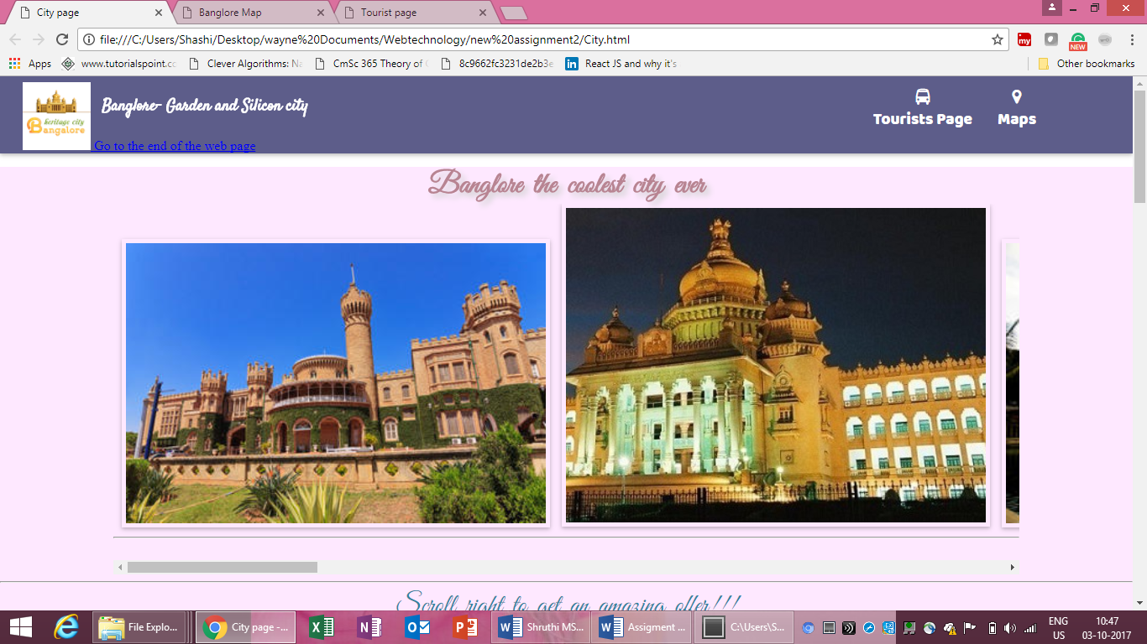

2.

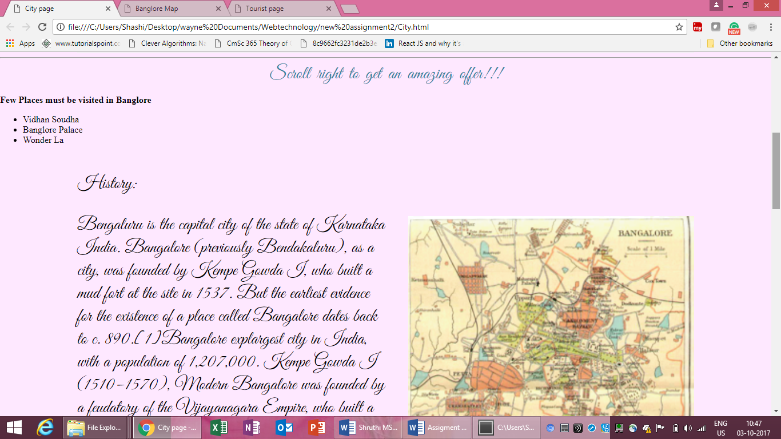

3. 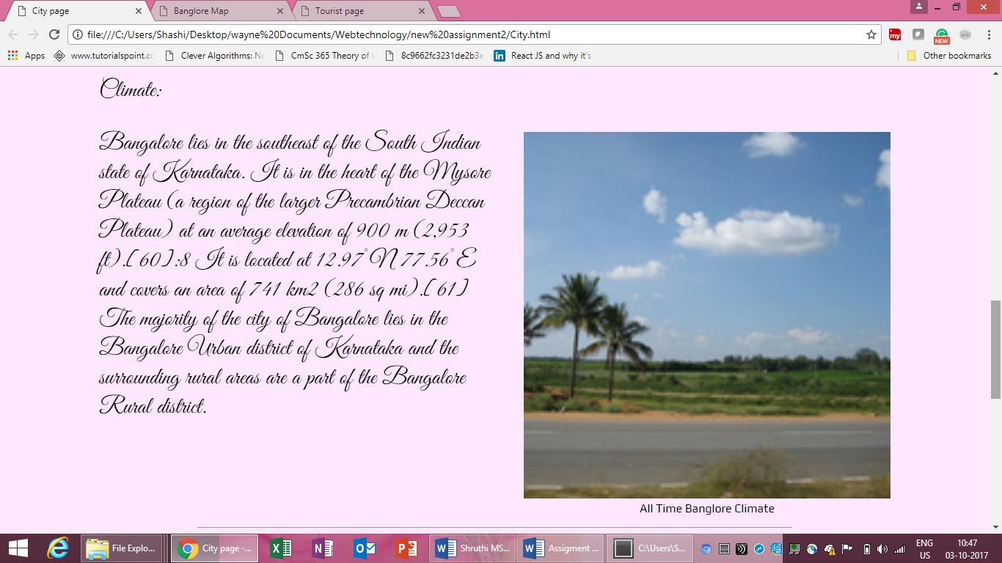

4.

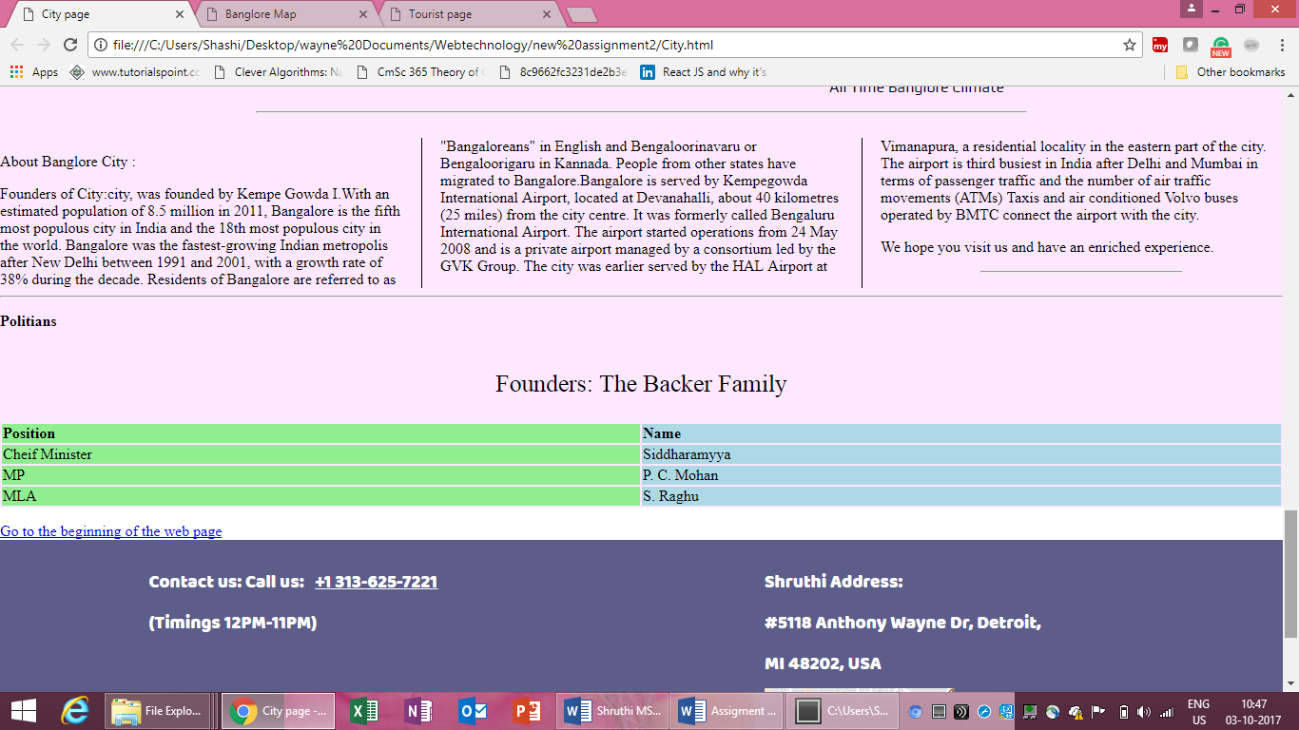

5. 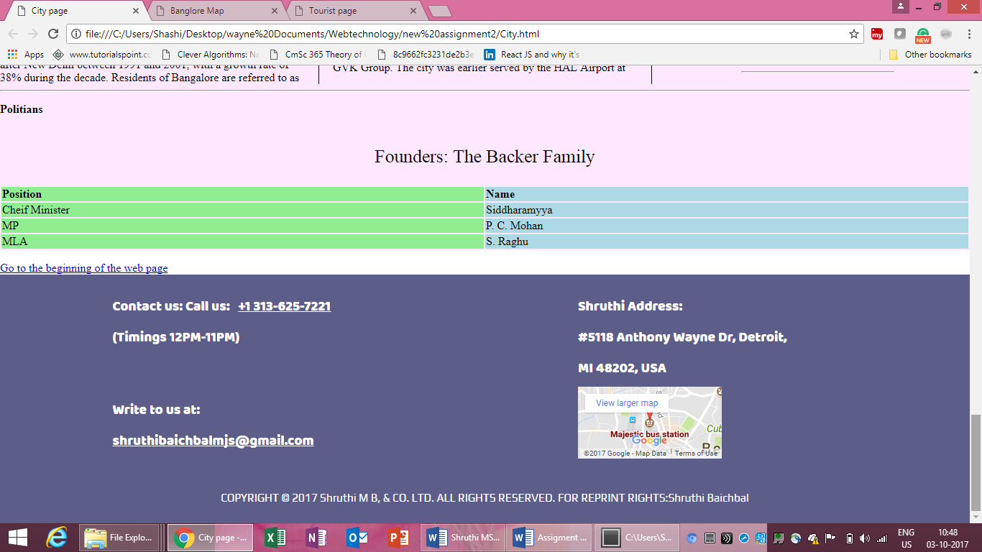

*[]\*\**

**Tourist page**

**Code Here**

*[<!DOCTYPE html>*

*<!--==================================================================*

*//*

*// Title: Webpage for Banglore City*

*// Course: CSC 5750*

*// Homework: 2*

*// Author: Shruthi Manappa Baichbal*

*// Date: 3 October 2017*

*// Description:*

*// The webpage talks about the Tourits Places, Important place to visit in banlore.*

*Image of the Tourits places and Their information ,It also contains the Bus infomration in this page.*

*THe Header has the Logo of Banglore, and links for the other 2 pages,i,e Tourist Page and Maps.*

*// Footer COntains information of the Web PageCreater, and Time to call the tourist consultant for any information*

*//*

*//=================================================================-->*

*<html>*

*<html>*

*<head>*

*<title>Tourist page</title>*

*<link rel="stylesheet" href="https://cdnjs.cloudflare.com/ajax/libs/font-awesome/4.7.0/css/font-awesome.min.css">*

*<link href="https://fonts.googleapis.com/css?family=Oswald|Satisfy|Baloo+Tammudu|Play|Tangerine" rel="stylesheet">*

*<link rel="stylesheet" type="text/css" href="Test.css">*

*</head>*

*<body>*

*<div class="body-wrapper">*

*<header>*

*<div class="logo-holder">*

*<a href="main.html">*

*<img src="image\banglorelogo.png">*

*<!--================================================================*

*// Pre-defined heading style h1*

*//===============================================================-->*

*<h1>Banglore- Garden and Silicon city </h1>*

*</a>*

*<!-- Link to another spot on this web page. The spot with ID*

*"EndOfPage" must exist somewhere in this HTML file. -->*

*<a href="#EndOfPage">Go to the end of the web page</a>*

*<p div id="BeginOfPage"></p>*

*</div>*

*<div class="header-list">*

*<ul>*

*<li><a href="Tourist page.html"><i class="fa fa-bus" aria-hidden="true"></i>Tourists Page</a></li>*

*<li><a href="Banglore Map.html"><i class="fa fa-map-marker" aria-hidden="true"></i>Maps</a></li>*

*</ul>*

*</div>*

*</header>*

*<!-- Link to an image file on this computer. The linked file must*

*exist in the same folder as the web page. -->*

*<div class="content-wrap">*

*<div class="menu-images">*

*<div class="inner-menu"><img src="image\Lal Bhag.jpg"></div>*

*<div class="inner-menu"><img src="image\Cubbon_Park_W.jpg"></div>*

*<div class="inner-menu"><img src="image\download.jpg"></div>*

*<div class="inner-menu"><img src="image\Hogenikal Falls.jpg"></div>*

*<div class="inner-menu"><img src="image\Manipal OCunty.jpg"></div>*

*<div class="inner-menu"><img src="image\Nandhi Hills2.jpg"></div>*

*<div class="inner-menu"><img src="image\VidhanSoudha.jpg"></div>*

*<div class="inner-menu"><img src="image\WOnderla2.jpg"></div>*

*</div>*

*<hr style="width: 80%;">*

*<hr style="width: 60%;">*

*<hr style="width: 40%;">*

*<hr style="width: 20%;">*

*<!--================================================================*

*// Tables*

*//===============================================================-->*

*<!--================================================================*

*// Table With No Column or Row Spanning*

*//===============================================================-->*

*<table style="border:2px; width:100%">*

*<!-- Caption -->*

*<caption>*

*<p style="font-size: 1.6em;">TravellersFacility</p>*

*</caption>*

*<!-- Column specs -->*

*<colgroup>*

*<col width="25%" style="background-color:LightPink">*

*<col width="25%" style="background-color:lightBlue">*

*</colgroup>*

*<!-- Column headers -->*

*<thead>*

*<tr>*

*<td>*

*<b>Name of the PLace :</b>*

*</td>*

*<td>*

*<b>Price from majestic(Bus)</b>*

*</td>*

*</tr>*

*</thead>*

*<!-- Rows and columns -->*

*<tbody>*

*<tr>*

*<td>*

*Vidhna Soudha*

*</td>*

*<td>*

*5$/Person*

*</td>*

*</tr>*

*<tr>*

*<td>*

*Banglore Palace*

*</td>*

*<td>*

*4$/person*

*</td>*

*</tr>*

*<tr>*

*<td>*

*Cubbon Park*

*</td>*

*<td>*

*6$ /Person*

*</td>*

*</tr>*

*<tr>*

*<td>*

*Iscon Temple*

*</td>*

*<td>*

*3$/Person*

*</td>*

*</tr>*

*<tbody>*

*</table>*

*<div class="sweet">*

*<h1>Important Tourist Places</h1>*

*<div class="sweet-flex">*

*<div class="inner-menu"><img src="image\Vidhanasoudha3.jpg"><span>Parliment</span></div>*

*<p>Kengal Hanumanthaiah is credited with the conception and construction of the Vidhana Soudha The foundation stone was laid by the then Prime Minister of India, Jawaharlal Nehru, on July 13, 1951.However, it was Hanumanthaiah who was instrumental in the redesign and speedy construction of Vidhana Soudha. He visited Europe, Russia, the United States, and other places and got the idea of building the Vidhana Soudha by incorporating various designs from the buildings he had seen. It was completed in 1956. He took a lot of interest and effort in building this marvelous granite building. It was meant to dwarf the British-built Athara Kacheri (High Court) building</P>*

*<div class="inner-menu"><img src="image\800px-ISKCON_Banglaore_Temple.jpg"><span>Iscon Temple</span></div>*

*<p> Around 1976, devotees from different parts of India and the world had initiated activities of ISKCON in different parts of South India like Bangalore, Hubli, Madras, etc. Sankirtans in the streets, enrolling Life Members, arranging programs in the houses, and arranging large public programs in pandals were being conducted. The society was registered in the year 1978 under the Karnataka Societies Registration Act, 1960. The objects of the society are derived from the Seven Purposes of ISKCON as stated by Srila Prabhupada. In May 1997, Bangalore ISKCON Temple was inaugurated by the ninth president of India - Shankar Dayal Sharma</p>*

*<div class="inner-menu"><img src="image\Cubbon_Park_W.jpg"><span>Cubbon Park</span></div>*

*<p> The park is accessible from M.G. Road, Kasturba road, Hudson Circle and Ambedkar Veedhi (Road). The motorable roads which run through the park are allowed for light motor vehicles only. All locations of the park are accessible through walking paths. The Park is open to the public at all times but the roads around the park are closed for traffic from 5:00 to 8:00 am every day to provide more safety and fresh environment for morning walkers and exercisers</p>*

*<div class="inner-menu"><img src="image\Palace.jpg"><span>Banglore Palace</span></div>*

*<p> The sprawling grounds surrounding the palace used to be used for holding public events including music concerts. Many international artists have performed in the grounds. Today a legal battle between government and the Mysore Royal family, has seen a band of commercial activities. Nevertheless, a number of private companies controlled by the royal family runs a number of wedding halls on the grounds.</p>*

*</div>*

*</div>*

*<hr style="width: 80%;">*

*<hr style="width: 80%;">*

*</body>*

*<!-- Link to another spot on this web page. The spot with ID*

*"BeginOfPage" must exist somewhere in this HTML file. -->*

*<p div id="EndOfPage"></p>*

*<a href="#BeginOfPage">Go to the beginning of the web page</a>*

*<!--================================================================*

*// Footer for every page containing contact information of the Resturant*

*//===============================================================-->*

*<!-- Font size, style and colour -->*

*<footer>*

*<div class="footer-wrapper">*

*<div class="timings">*

*<span> Contact us:</span>*

*Call us: &nbsp; <a href="tel:+1 313-625-7221"><span>+1 313-625-7221</span></a> &nbsp;*

*(Timings 12PM-11PM)*

*<div class="mail-us">*

*Write to us at:*

*<!--================================================================*

*// E-mail link*

*//===============================================================-->*

*<a href="mailto:shruthibaichbalmjs@gmail.com">shruthibaichbalmjs@gmail.com</a>*

*</div>*

*</div>*

*<div class="address">*

*<span>Shruthi Address:</span>*

*<br>*

*#5118 Anthony Wayne Dr, Detroit,*

*<br>*

*MI 48202, USA*

*<div>*

*<iframe src="https://www.google.com/maps/embed?pb=!1m18!1m12!1m3!1d7775.82854462199!2d77.56679172345687!3d12.977334763408285!2m3!1f0!2f0!3f0!3m2!1i1024!2i768!4f13.1!3m3!1m2!1s0x0%3A0xac09bf4a9dea9e16!2sMajestic+bus+station!5e0!3m2!1sen!2sus!4v1507007487934" width="200" height="100" frameborder="0" style="border:0" allowfullscreen></iframe>*

*</div>*

*</div>*

*<div class="copyright">*

*COPYRIGHT © 2017 Shruthi M B, & CO. LTD. ALL RIGHTS RESERVED. FOR REPRINT RIGHTS:Shruthi Baichbal*

*</div>*

*</div>*

*</footer>*

*</body>*

*</html>]\**

**If possible, format your code like this:**

**Font “Courier New”**

**Font size “9”**

**Bold**

*[Screenshots Here]\*\**

*1.* 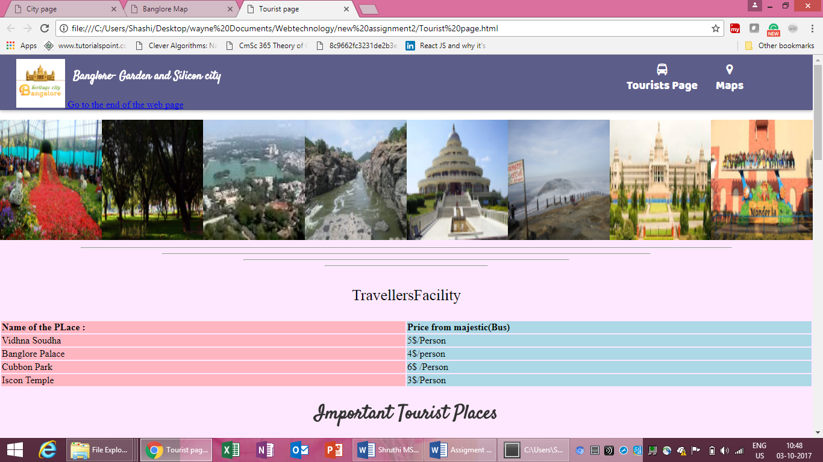

1. 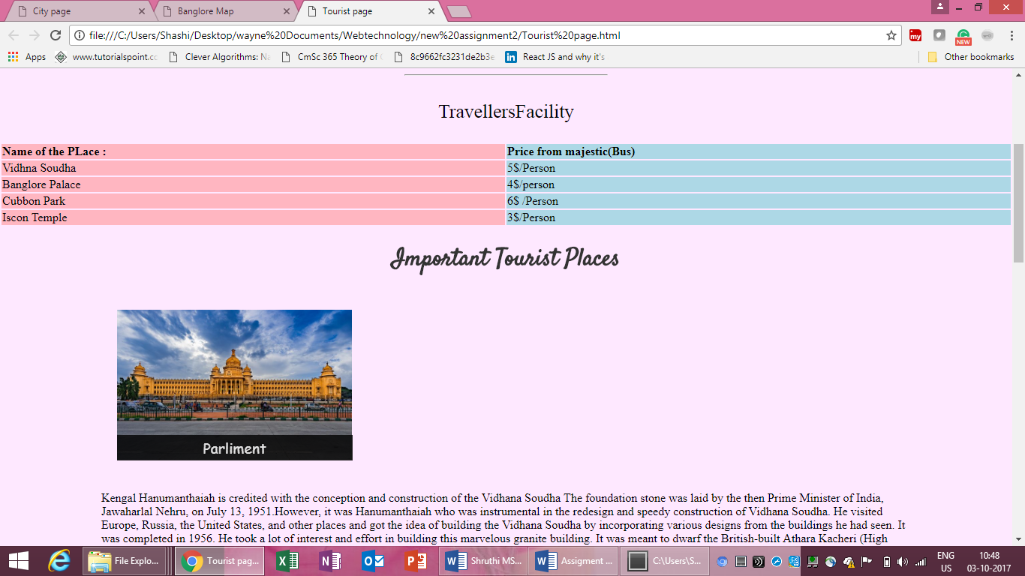

*3.*

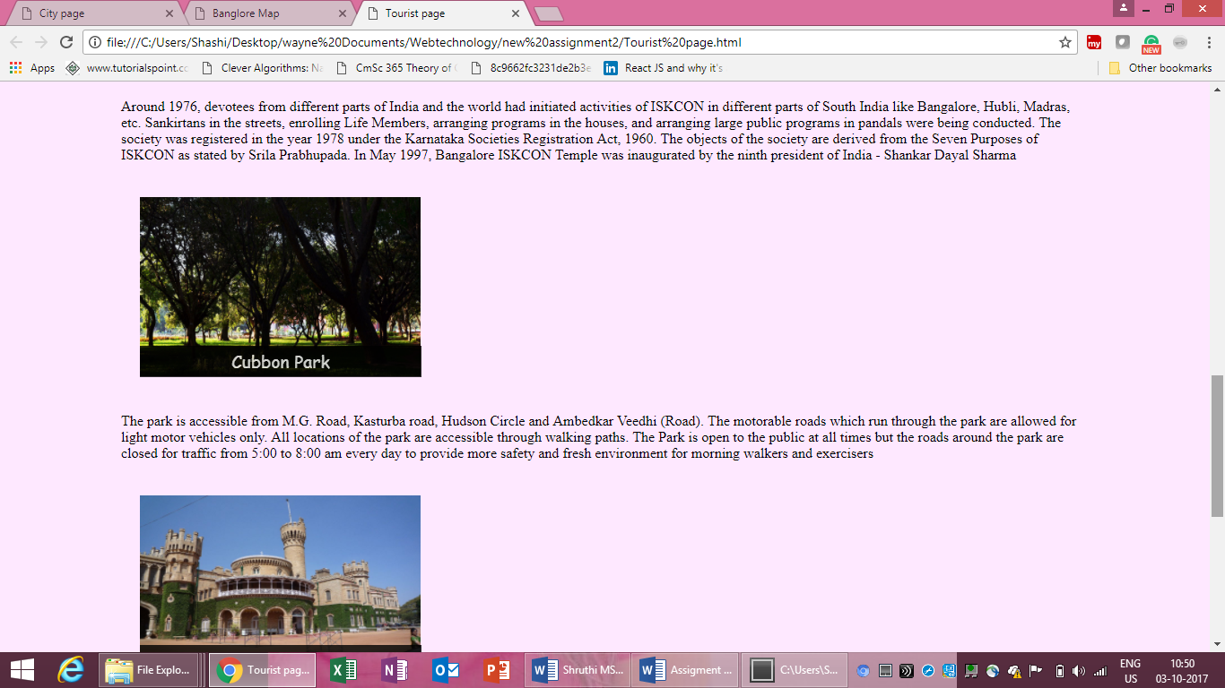

*4.*

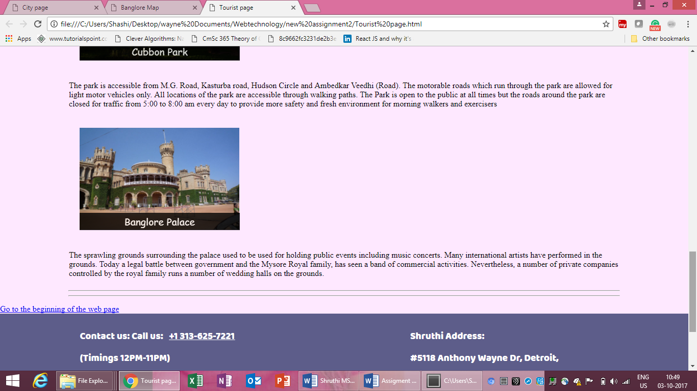

5. 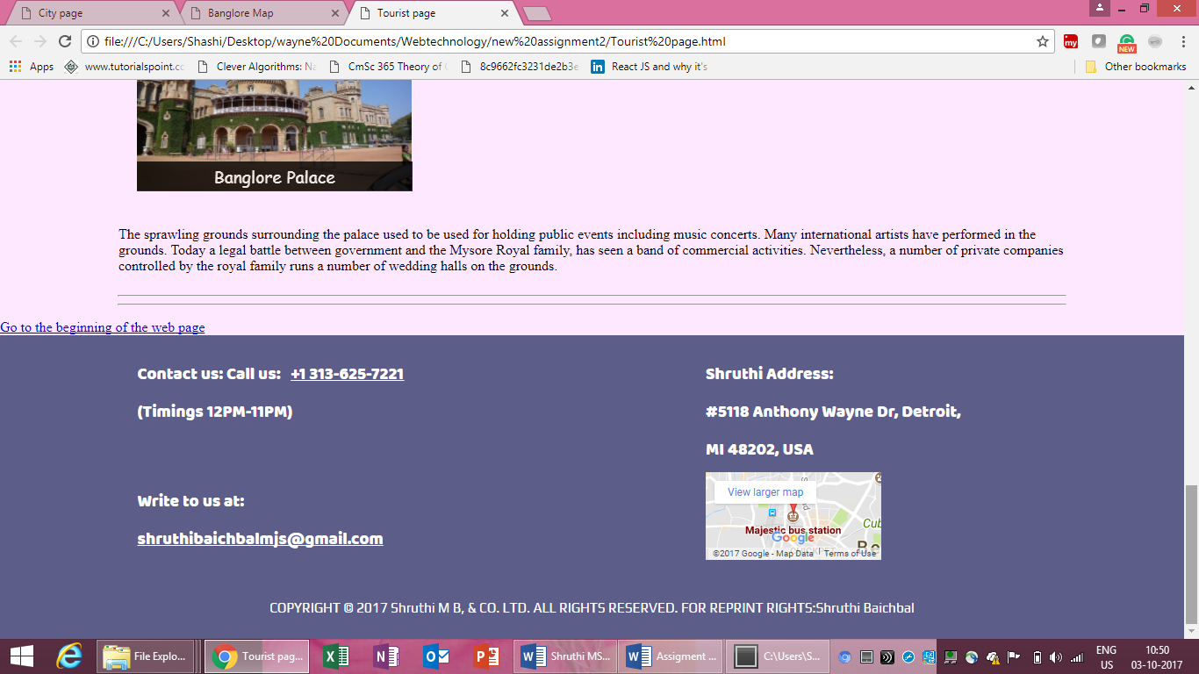

**Map page Code Here**

*[*

*<!DOCTYPE html>*

*<!--==================================================================*

*//*

*// Title: Webpage for Banglore City*

*// Course: CSC 5750*

*// Homework: 2*

*// Author: Shruthi Manappa Baichbal*

*// Date: 3 October 2017*

*// Description:*

*// The webpage talks about the Banglore City Map.THis page has Header which contains the logo of the city,, And links to the other page.*

*Body consists of the BAnglore Map*

*Footer COntains information of the Web PageCreater, and Time to call the tourist consultant for any information*

*//*

*//*

*//=================================================================-->*

*<html>*

*<head>*

*<title>Banglore Map</title>*

*<link rel="stylesheet" href="https://cdnjs.cloudflare.com/ajax/libs/font-awesome/4.7.0/css/font-awesome.min.css">*

*<link href="https://fonts.googleapis.com/css?family=Oswald|Satisfy|Baloo+Tammudu|Play|Tangerine" rel="stylesheet">*

*<link rel="stylesheet" type="text/css" href="Test.css">*

*</head>*

*<body>*

*<div class="body-wrapper">*

*<header>*

*<div class="logo-holder">*

*<a href="main.html">*

*<img src="image\banglorelogo.png">*

*<!--================================================================*

*// Pre-defined heading style h1*

*//===============================================================-->*

*<h1>Banglore- Garden and Silicon city </h1>*

*</a>*

*<!-- Link to another spot on this web page. The spot with ID*

*"EndOfPage" must exist somewhere in this HTML file. -->*

*<a href="#EndOfPage">Go to the end of the web page</a>*

*<p div id="BeginOfPage"></p>*

*</div>*

*<div class="header-list">*

*<ul>*

*<li><a href="Tourist page.html"><i class="fa fa-bus" aria-hidden="true"></i>Tourists Page</a></li>*

*<li><a href="Banglore Map.html"><i class="fa fa-map-marker" aria-hidden="true"></i>Maps</a></li>*

*</ul>*

*</div>*

*</header>*

*<!-- Link to an image file on this computer. The linked file must*

*exist in the same folder as the web page. -->*

*<div class="content-wrap">*

*<iframe src="https://www.google.com/maps/embed?pb=!1m18!1m12!1m3!1d7775.82854462199!2d77.56679172345687!3d12.977334763408285!2m3!1f0!2f0!3f0!3m2!1i1024!2i768!4f13.1!3m3!1m2!1s0x0%3A0xac09bf4a9dea9e16!2sMajestic+bus+station!5e0!3m2!1sen!2sus!4v1507007487934" width="800" height="500" frameborder="0" style="border:0" allowfullscreen></iframe>*

*<hr style="width: 80%;">*

*<hr style="width: 80%;">*

*</body>*

*<!-- Link to another spot on this web page. The spot with ID*

*"BeginOfPage" must exist somewhere in this HTML file. -->*

*<p div id="EndOfPage"></p>*

*<a href="#BeginOfPage">Go to the beginning of the web page</a>*

*<!--================================================================*

*// Footer for every page containing contact information of the Resturant*

*//===============================================================-->*

*<!-- Font size, style and colour -->*

*<footer>*

*<div class="footer-wrapper">*

*<div class="timings">*

*<span> Contact us:</span>*

*Call us: &nbsp; <a href="tel:+1 313-625-7221"><span>+1 313-625-7221</span></a> &nbsp;*

*(Timings 12PM-11PM)*

*<div class="mail-us">*

*Write to us at:*

*<!--================================================================*

*// E-mail link*

*//===============================================================-->*

*<a href="mailto:shruthibaichbalmjs@gmail.com">shruthibaichbalmjs@gmail.com</a>*

*</div>*

*</div>*

*<div class="address">*

*<span>Shruthi Address:</span>*

*<br>*

*#5118 Anthony Wayne Dr, Detroit,*

*<br>*

*MI 48202, USA*

*<div>*

*<iframe src="https://www.google.com/maps/embed?pb=!1m18!1m12!1m3!1d7775.82854462199!2d77.56679172345687!3d12.977334763408285!2m3!1f0!2f0!3f0!3m2!1i1024!2i768!4f13.1!3m3!1m2!1s0x0%3A0xac09bf4a9dea9e16!2sMajestic+bus+station!5e0!3m2!1sen!2sus!4v1507007487934" width="200" height="100" frameborder="0" style="border:0" allowfullscreen></iframe>*

*</div>*

*</div>*

*<div class="copyright">*

*COPYRIGHT © 2017 Shruthi M B, & CO. LTD. ALL RIGHTS RESERVED. FOR REPRINT RIGHTS:Shruthi Baichbal*

*</div>*

*</div>*

*</footer>*

*</body>*

*</html>]\**

**If possible, format your code like this:**

**Font “Courier New”**

**Font size “9”**

**Bold**

Map Page Screenshots here.

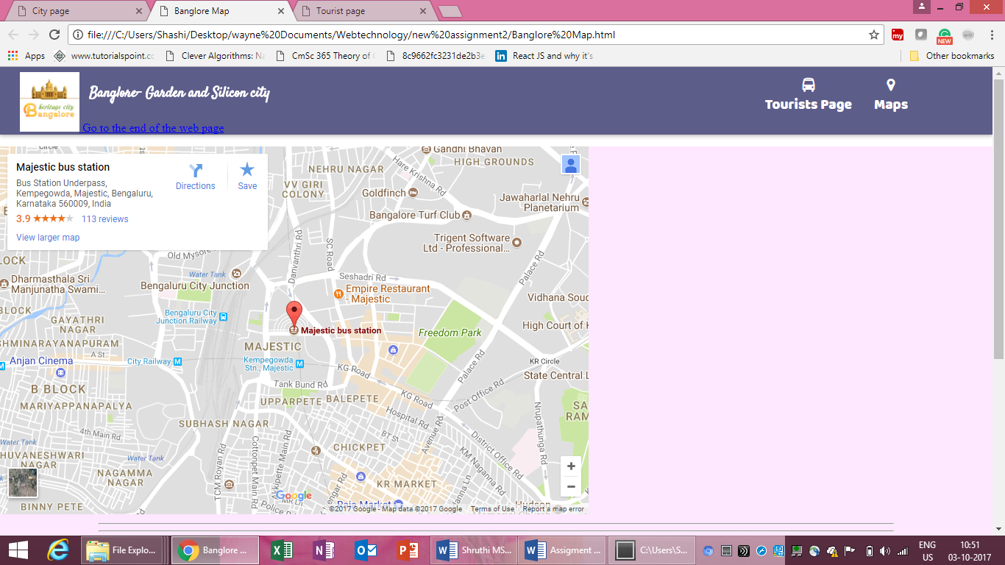

2. 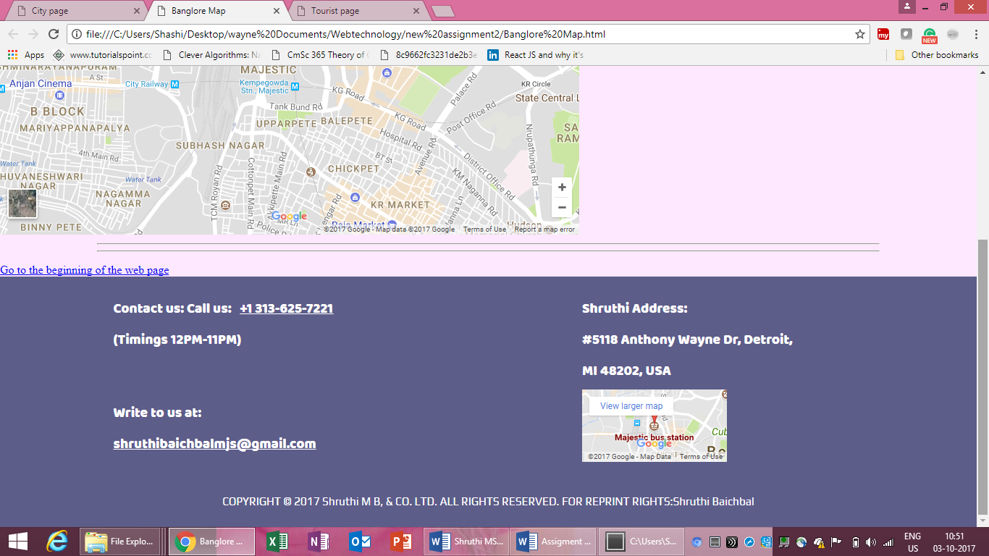

**CSS file File Code Here**

*body{*

*margin: 0;*

*}*

*.body-wrapper {*

*width: 100%;*

*height: 100%;*

*min-height: 100vh;*

*margin:0;*

*}*

*header{*

*box-shadow: 0 2px 5px 0 rgba(0,0,0,0.16), 0 2px 10px 0 rgba(0,0,0,0.12);*

*position: relative;*

*clear:both;*

*background-color: #5d5d8a;*

*background-image:url(image/city.png');*

*}*

*.logo-holder{*

*width: 40%;*

*padding:.5% .5% 0 2%;*

*}*

*.logo-holder img{*

*width: 15%;*

*display: inline;*

*}*

*.logo-holder h1{*

*position: absolute;*

*top:10%;*

*left: 9%;*

*font-size:1.2em;*

*font-family: 'Satisfy', cursive;*

*color:white;*

*}*

*.header-list{*

*position: absolute;*

*top:10%;*

*right:2%;*

*width: 25%;*

*}*

*.header-list ul{*

*overflow: hidden;*

*margin:0;*

*font-family: 'Baloo Tammudu', cursive;*

*font-size: 1.2em;*

*}*

*.header-list li{*

*padding:2% 5% ;*

*display: block;*

*float: left;*

*list-style-type: none;*

*color: #ffd72b;*

*}*

*.header-list i{*

*display: block;*

*text-align: center;*

*}*

*.header-list a{*

*text-decoration: none;*

*color: white;*

*}*

*a:hover{*

*color:yellow;*

*}*

*.content-wrap{*

*position: relative;*

*margin-top:.5%;*

*background: #fee8ff;*

*}*

*.deal-h1{*

*text-align: center;*

*font-family: 'Great Vibes', cursive;*

*color: #b88492;*

*font-size:2.2em;*

*text-shadow:5px 5px 10px lightgrey;*

*word-spacing: 4px;*

*margin:0.5px;*

*}*

*.main-images{*

*margin-left: auto;*

*margin-right: auto;*

*width:80%;*

*position: relative;*

*overflow-x: scroll;*

*}*

*.scroller{*

*position: relative;*

*width:5000px;*

*}*

*.scroll-right{*

*width: 50%;*

*margin:auto;*

*text-align: center;*

*font-family: 'Great Vibes', cursive;*

*font-size:2em;*

*word-spacing: 4px;*

*color:#30849f;*

*}*

*.offers{*

*position: absolute;*

*/*display: inline;*/*

*font-family: 'Great Vibes', cursive;*

*font-size:1.8em;*

*background:white;*

*padding:.1%;*

*}*

*.offers1{*

*top:2%;*

*left: .3%;*

*width:5.5%;*

*}*

*.offers-last{*

*right: 2%;*

*top: 0;*

*width: 12%;*

*padding: 1%;*

*font-size: 3em;*

*color:#dd6277;*

*}*

*.offers-last a{*

*color:#dd6277;*

*}*

*.large-img{*

*width:10%;*

*padding:.1%;*

*height:100%;*

*margin-left:.2%;*

*box-shadow: 0 2px 5px 0 rgba(0,0,0,0.16), 0 2px 10px 0 rgba(0,0,0,0.12);*

*}*

*.history{*

*width:40%;*

*margin:auto;*

*font-family: 'Great Vibes', cursive;*

*font-size:2em;*

*float: left;*

*margin-left: 10%;*

*}*

*.about{*

*font-family: 'Great Vibes', cursive;*

*font-size:2em;*

*width:80%;*

*margin:auto;*

*}*

*.owners{*

*font-family: 'Baloo Tammudu', cursive;*

*width:50%;*

*font-size:1.5em;*

*margin:auto;*

*text-align: center;*

*color:#333;*

*}*

*/*menu */*

*.menu-images{*

*display: flex;*

*width:100%;*

*}*

*.inner-menu{*

*width:30%;*

*}*

*.inner-menu img{*

*width: 100%;*

*height:200px;*

*}*

*.sweet{*

*width:80%;*

*margin:auto;*

*}*

*.sweet h1{*

*font-family: 'Satisfy', cursive;*

*color:#333;*

*text-align: center;*

*}*

*.sweet-flex{*

*display: flex;*

*flex-direction: row;*

*flex-wrap: wrap;*

*}*

*.sweet-flex .inner-menu{*

*width: 29%;*

*padding:2%;*

*position: relative;*

*}*

*.sweet-flex .inner-menu span{*

*position:absolute;*

*bottom:10%;*

*left:6%;*

*width: 86%;*

*background-color: #000;*

*color: #fff;*

*opacity: 0.8;*

*text-align: center;*

*padding:1%;*

*font-family: 'Great Vibes', cursive;*

*font-size: 1.2em;*

*}*

*.footer-wrapper{*

*padding:2%;*

*background-color: #5d5d8a;*

*display: -webkit-box;*

*display: -moz-box;*

*display: -ms-flexbox;*

*display: -webkit-flex;*

*display: flex;*

*-webkit-flex-flow: row wrap;*

*justify-content: space-around;*

*color:white;*

*font-family: 'Baloo Tammudu', cursive;*

*font-size:1.2em;*

*}*

*.timings, .address, .reviews{*

*width:30%;*

*}*

*.timings a{*

*color:white;*

*}*

*.mail-us{*

*margin-top:15%;*

*}*

*.reviews p{*

*margin:0;*

*font-family: 'Satisfy', cursive;*

*font-size:1em;*

*}*

*.copyright{*

*margin-top:2%;*

*font-family: 'Play', sans-serif;*

*font-size:.8em;*

*}*

*.reservation{*

*font-family: 'Play', sans-serif;*

*font-size: 1.5em;*

*width: 70%;*

*margin:auto;*

*}*

*.multicolumn {*

*-webkit-column-count: 3; /* Chrome, Safari, Opera */*

*-moz-column-count: 3; /* Firefox */*

*column-count: 3;*

*-webkit-column-gap: 40px; /* Chrome, Safari, Opera */*

*-moz-column-gap: 40px; /* Firefox */*

*column-gap: 40px;*

*-webkit-column-rule-style: solid; /* Chrome, Safari, Opera */*

*-moz-column-rule-style: solid; /* Firefox */*

*column-rule-style: solid;*

*-webkit-column-rule-width: 1px; /* Chrome, Safari, Opera */*

*-moz-column-rule-width: 1px; /* Firefox */*

*column-rule-width: 1px;*

*}*